Name: Date:
Period:

OXYGEN: PREPARATION & PROPERTIES

PRE-LAB DISCUSSION:
Oxygen is one of the most abundant of all elements. It is found in the earth’s crust combined with most other elements. It is also present in elemental (diatomic) form in the atmosphere. In addition to being plentiful, oxygen is a highly reactive element. It combines with most other elements by gaining or sharing two electrons.
In this experiment, we will produce oxygen by the decomposition of hydrogen peroxide, using manganese dioxide as a catalyst. The gas will be collected using the water displacement method, and you will investigate one of the oxygen’s properties.

I. OBJECTIVE:
Prepare oxygen and investigate how it reacts with a glowing splint.

II. MATERIALS & EQUIPMENT:
3% Hydrogen Peroxide 1-#4, 2 hole stopper
Manganese dioxide rubber tubing scoopula
Tap water matches/sparker balance
Wooden splints ring stand bent glass tube
1 large test tube glycerin Erlenmeyer flask
2-3 small test tubes massing paper thistle tube
250mL beaker clamp

III. PROCEDURE:
1. Mass out 1.00 g of manganese dioxide on a piece of massing paper. Pour into to 250mL Erlenmeyer flask.
2. Measure 25mL of water with a graduated cylinder and pour into the flask.
3. Clamp the Erlenmeyer flask to the ring stand.
4. Insert the thistle tube and bent glass rod into the two-holed rubber stopper using glycerin as a lubricant. Your hands must be kept close together when inserting the glass rod. Otherwise it may break and go through your hand.
5. Insert the two-hole into the Erlenmeyer flask, so the bottom thistle tube is below the water line.
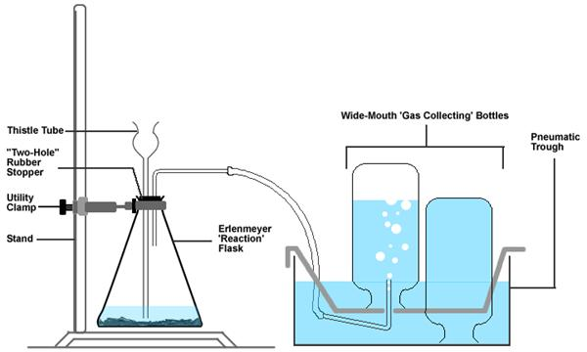
6. Fill the collection bath with water and submerge the 3 gas collection test tubes in the bath. Attach the hose from the bath to the glass tube in the 2-holed rubber stopper.
7. Measure about 200mL of 3% hydrogen peroxide, and slowly pour this into the thistle tube. Be careful not to make it overflow. If at any time the rate of the reaction in the Erlenmeyer flask appears to slow down, add another 10-mL portion of H₂O₂.
8. After about 80 bubbles have escaped from the tube, take a second test tube, fill it with water and place it over the rubber collection tube. Allow the water to be displaced by the oxygen until the tube is full of the oxygen gas. Fill as many test tubes as you can.
9. Next, take a wood splint and set it on fire. Then, blow out the flame, but make sure the splint remains glowing. Now, pick up the test tube of oxygen gas, turn it horizontally and quickly place the glowing splint to the mouth of the test tube.

Additional Instructor Experiments-
10. Take a small ball of steel wool with crucible tongs, light it on fire and insert it into the test tube (pointed away from every one) while its lit.
11. Light a small strip of magnesium, using the same method in step 9.

IV. QUESTIONS:
1. What is a chemical catalyst?
2. What is the purpose of waiting for 80 bubbles to escape from the gas collection tube before collecting the oxygen gas?
3. What did you observe when you placed the glowing splint in the presence of the oxygen gas?
4. What difference did you observe between the reactions of Magnesium in the air versus the reaction in pure oxygen?
5. What difference did you observe between the reactions of steel wool in the air versus the reaction in pure oxygen?
6. Write the 2 balanced chemical reactions of the questions 4 and 5. (You may use the internet or text books.)

V: CONCLUSION

